**Github Flow**

1. There will be three main branches in each project/repo. master, qa, and develop.
2. All commits should migrate in order. i.e., **develop → qa → master**.
3. Whenever a new bug / new feature / enhancement is placed, developer/QA should create an issue for that in GitHub. If the project has no dedicated QA or BA, the developer should take the initiative to create an issue in GitHub and work on that.

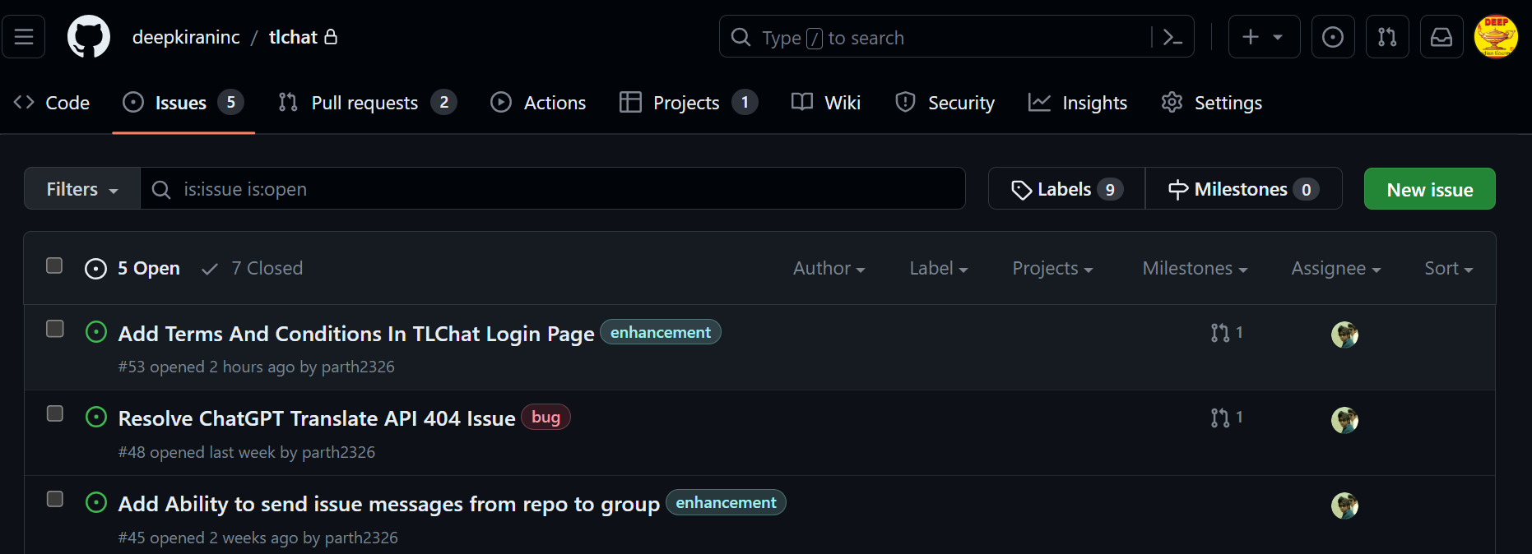

1. Create a branch for that particular issue. **Each branch should have an issue number as prefix. And each commit within that branch should also include the issue number as prefix.**

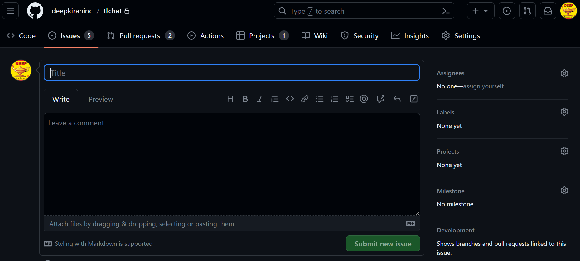

1. The new branch (issue branch) should be a sub branch of develop (branch). You can easily create branch names from options given in the GitHub interface.

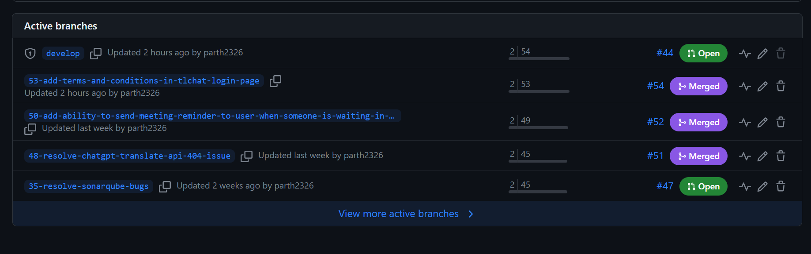

1. We require **minimum one approval from the other developer to merge the pull request.**
2. Each pull request start from develop should be named in a way that denotes the movement of the commits.

**Eg. develop to qa**

**qa to master**

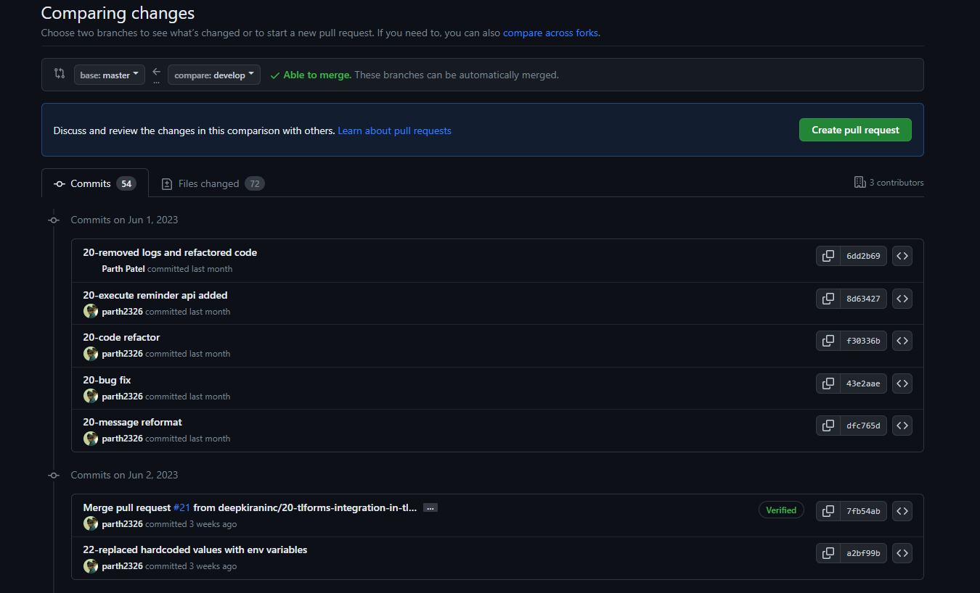

1. Try to give proper labels to your issues. Eg. If the issue is a bug, label it as a bug.



1. For QA and BA, if they are creating issues, try to add screenshots and also try to add details like expected output. This will help developers understand the exact issue and what should be the expected output.
2. If a developer is creating a new API, try to add API paths and parameters to the issue so that it can be referenced later.
3. If any project is still using the local tortoise SVN then the responsible developer should start migrating their code/projects to GitHub as soon as possible with all the checklist followed.